SUBJECT: **MUSIC** LEVEL: Form 3

CURRICULUM TOPIC: Tempo (Activity 3)

Tempo terms are written **above** the music score at the beginning of the music. If the tempo changes in the music, the appropriate term is written **by** the place where the change occurs.

* Show that this music is played at a walking pace and slows down in bar 4.

Andante rit…………………

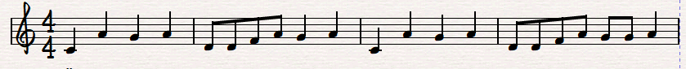

[The arrows above show where the Italian terms are placed above the music score].

ACTIVITY 3

* Show that this piece is played quickly and gradually gets slower from Bar 8. Write in the Italians terms for the underlined words in the appropriate places.

*1. We Wish You A Merry Christmas – Traditional carol*

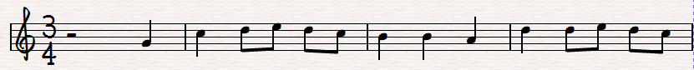

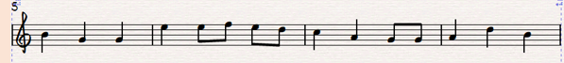

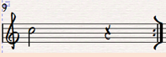

* Show that this piece is to be played slowly.

2. Canon in D

Johann Pachelbel (extract)



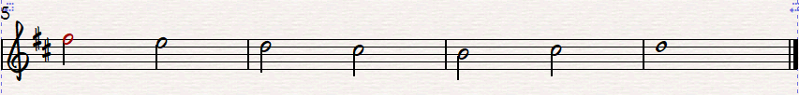

Did you get them out?

Click here

Italian terms for Tempo answer

Activity prepared by Michele Dowrich, Curriculum Officer VAPA, CPDD, Ministry of Education 042020