**ELECTROMAGNETISM**

**ELECTRICAL AND ELECTRONIC TECHNOLOGY**

When current passes through a conductor, there is a magnetic field around the conductor. The magnetic field around the conductor takes the shape of concentric field lines (**fig 5em**). The direction of these field lines are determined by applying the “**right hand grip rule**”.

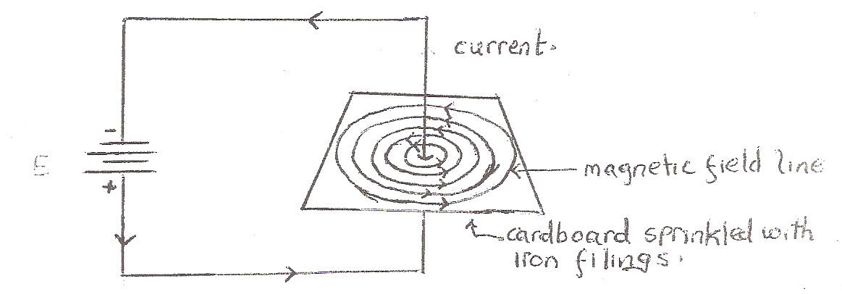

**Fig 5em**

**Right hand grip rule**

The right hand grip rule helps determine the direction of the magnetic field lines. The right hand grip rule is as follows:

Grip the conductor in the right hand with the thumb pointed in the direction of the conventional current flow, the fingers would be curled in the direction of the magnetic field lines, fig 6em. The field lines are in the clockwise direction in fig 6em. 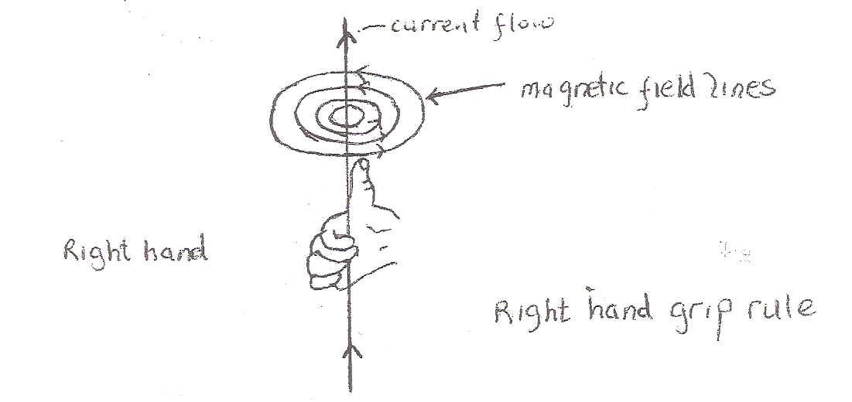

Fig 6em

**THE ELECTROMAGNET**

By coiling the conductor, we strengthen the magnetic field. **A coil that is used to function as a magnet is called an electromagnet.** The magnetic field around an electromagnet when it carries a current is shown in **fig 7em**, below. The direction of the field lines is determined by applying the “right hand grip rule for an electromagnet.

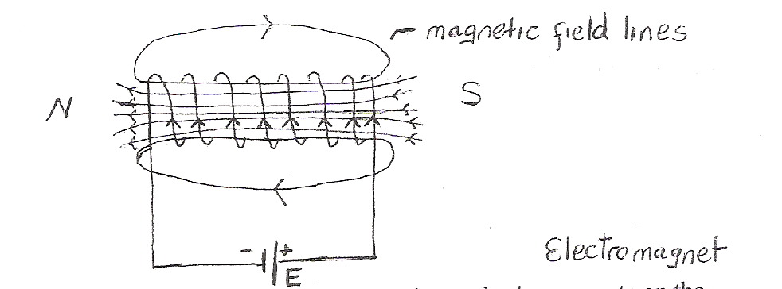

**Fig 7em**

Electric bells, buzzers, door chimes, automatic switches and relays operate on the principle of electromagnetism.

**The process by which we produce magnetism by passing an electric current through a wire or coil (conductor) is defined as the electromagnetic effect.**

**Right hand grip rule for an electromagnet**

This rule determines the direction of the magnetic field or magnetic poles of the electromagnet.

Grasp the coil in the right hand with the fingers curled in the direction of the conventional current flow. The thumb as a result of this grip points in the direction of the North Pole. This is shown in **fig 8em**.

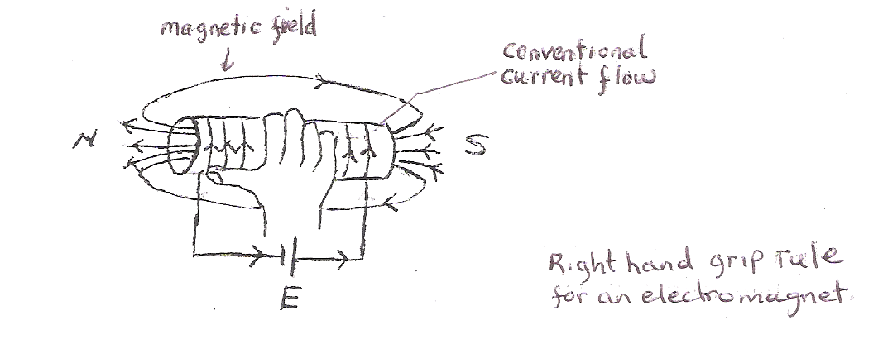

**Knowledge Check**

1. What is an electro-magnet?
2. What rule is applied to determine the Magnetic poles of an electromagnetic coil?

**Fig 8em**

**THE TREMBLER BELL**

The trembler bell operates on the principle of electromagnetism. The trembler bell circuit consists of the following components:

* Electromagnets or coils
* Armature
* Striker
* gong
* Adjustable screw contacts
* Bell push

**The trembler bell operates as follows:**

* When the push switch is first pressed. Current takes the path as shown in **fig 9em** through the electromagnet
* The electromagnet becomes magnetized, and attracts the armature
* The striker as a result of the armature movement, strikes the gong
* The armature movement breaks the contact point and causes the electromagnet to demagnetize
* The flat spring connected to the armature pull the armature back to its original position causing the contact points to make contact once again
* The coils are once again magnetized, and the armature attraction causes the gong to be struck by the striker
* The make and break action continues until the bell push switch is released.

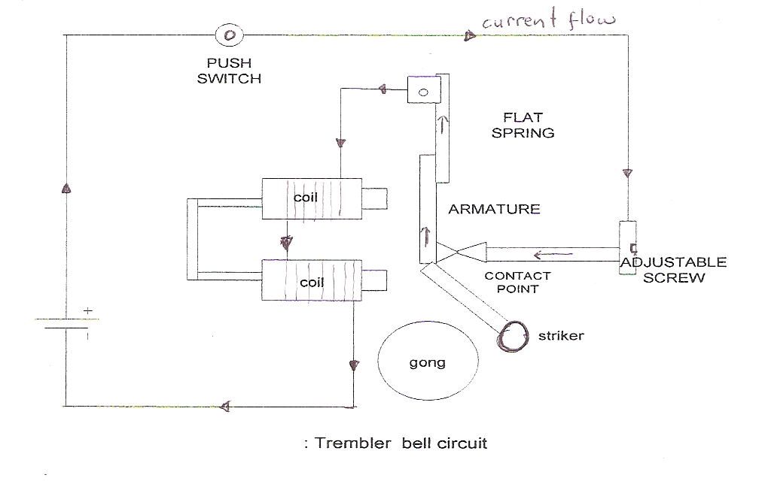

**Fig 9em**

**Activity/Questions**

1. Many bells used in secondary schools are trembler bells. Ask your Teacher to take you to observe the school bell just before it rings and if possible you can observe its external construction
2. The switch used to control the circuit is a push switch, why was this switch used.
3. The ringing sound from the Trembler bell is continuous, how is the ringing sound stopped?

**THE RELAY**

A relay is a simple electromagnetic switch, made up of an electromagnet and a set of contacts. There are four main parts of a relay:

* Electromagnet
* Armature: which is attracted to the electromagnet when coils are energized
* Spring
* Set of electrical contacts

**OPERATION**

When a current flows through the coil shown in **fig 10em**, the resulting magnetic field attracts an armature that is mechanically linked to a moving contact. The movement either makes or breaks a connection with a fixed contact.

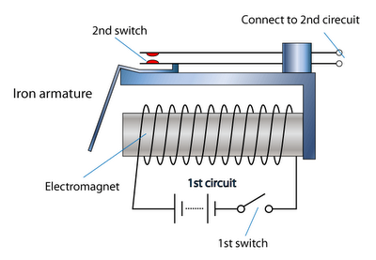

S1

Relay contact

RELAY

**Diagram of a relay**

**Fig 10em**

**OPERATION**

When a current flow through the coils, the resulting magnetic field attracts iron armature that is mechanically linked to the moving contacts. When the current to the coils is switched off, the armature returns to its relaxed position. This is done usually by a spring; however, gravity is also used commonly in industrial motor starters. Relays are manufactured to operate quickly. In low voltage applications the quick contact action is necessary is to reduce noise. In high voltage applications, the quick action is to reduce arcing.

The contacts can be **Normally Open (NO)** **or Normally Closed (NC)**, or **change over contacts,**

**fig 11em(a), (b), (c)**.

* Normally-open contacts connect the circuit when the relay is activated; the circuit is disconnected when the relay is inactive. It is also called a Form A contact or “make” contact. **Form A** contact is ideal for applications that require to switch a high-current power source from a remote device.
* Normally closed contacts disconnect the circuit when the relay is activated; the circuit is connected when the relay is inactive. It is also called Form B contact or “break” contact. Form B contact is Ideal for applications that require the circuit to remain closed until the relay is activated.
* Change-over contacts control two circuits: one normally open contact and one normally closed contact with a common terminal. It is also called Form C contact or “transfer” contact.

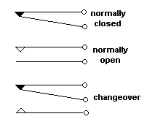(c)

(a)

(b)

**Relay contact configurations**

**Fig 11em**

**USES OF RELAYS**

**Relay are used to :**

* Control a high-voltage circuit with a low voltage signal, as in some types of modems and industrial machine circuits
* Control a high current circuit with a low current signal, as in the starter solenoid of an automobile.
* To detect and isolate faults on transmission and distribution lines by opening and closing circuit breakers (protection relays)
* Isolate the controlling circuit from the power circuit when the two are at different potentials, for example, when controlling a mains-powered device from a low-voltage switch.
* Relays are also used where multiple switching is required to conduct various circuit switched operations.

**SIMPLE RELAY CIRCUIT APPLICATION**

V=500v **power circuit**



**RELAY**

6v

**motor**

**Control circuit**

**Relay circuit used to power a high voltage motor circuit.**

**Figure 12em**

One of the main applications of a relay is the control of a large power circuit with a low power circuit.

**Fig 12em**, illustrates this basic application. A 6volt dc power source is connected to the electromagnet circuit via a switch S1. This circuit is referred to as the **control circuit**. When an operator depresses S1 in the control circuit, the electromagnetic circuit is energized, and causes the normally open relay contact to close. The closing of the relay contact engages the high 500v motor circuit which is then able to function.

You may ask, why not just connect the motor directly to a high 500volt power circuit, and energize it by a switch. Well this circuit has an added safety feature; in that the person energizing the motor circuit, indirectly through the control circuit S1, is exposed only to a low control voltage of 6volts, which protects him from danger of serious shock if there is a fault in the circuit such as a ground fault. If he switched on the motor circuit directly with a switch in the power circuit, the operator may be in serious danger if a circuit fault did occur in the power circuit.

It should be understood that although the relay coil is energized with a low voltage source, the relay contact is designed in this instant to engage a high voltage circuit. When purchasing a relay therefore, not only should the coil energizing voltage be known, but also the maximum relay contact voltage which the contacts can withstand.

**Activity/ Questions**

1. With the supervision of your parent, switch on the car and operate the automatic windows. Do you hear a switching sound when you depress the window switch? The switching sound you hear are the relay contacts.
2. Why is the relay circuit in fig 12em safe for the operator?