DAIRY CATTLE | JERSEY  HOLSTEIN  JAMAICA HOPE | Jerseys come in all shades of brown, from light tan to almost black. All purebred Jerseys have a lighter band around their muzzle, a dark switch (long hair on the end of the tail), and black hooves, they are regarded very favorably because of its milk and butterfat production.  BREEDS OF LIVESTOCK  The Holstein (may also be known as Holstein-Friesian or Friesian) is a breed of dairy cow known today as the world's highest production dairy animal. Holsteins have very distinctive markings and outstanding milk production. They are large animals with color patterns of black and white. In the strictest definition, a Holstein cow usually has black ears, white feet, and white end of the tail.  Jamaica Hope (also known as Jersey-Zebu or Montgomery-Jersey) is a dairy breed of cattle originating from Hope Farm in Jamaica. It is heat tolerant, has high resistance to ticks and tick borne diseases, and can produce much milk even in the poor pasture land typical of tropical climates. The Jamaican Hope is the only tropical dairy breed that results from crossing Zebu with regular cattle | 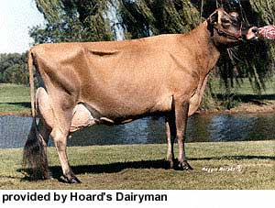  JERSEY  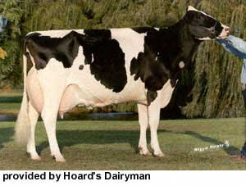  HOLSTEIN  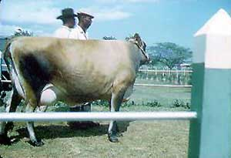  JAMAICA HOPE
BEEF CATTLE | JAMAICA RED  JAMAICA BLACK  CHARBRAY  CHAROLAIS  ZEBU | The Jamaica Red was developed from Red Poll cattle with limited amounts of zebu breeding introduced to increase the adaptation of the breed to the climate.  In the early 1900's Angus were imported to the island of Jamaica. Breeds which with zebu breeding were already in use so naturally the zebu were mated with the imported Angus. The result is a breed more similar in appearance to Brangus than Angus. The breed is 1/4 to 3/8 zebu. They are polled and have a slight cervical hump. Jamaica Black cattle also have more skin in the dewlap and underline than Brangus.  The Australian Charbray is a beef breed of cattle that is the result of the blending of two breeds, the Charolais and the Brahman. The Charbray is a large breed that is heavily muscled in the loin and quarters.  Charolais cattle are a beef breed of cattle (Bos taurus) which originated in Charolais, around Charolles, in France. Charolais tolerate heat well, and show good weight gains on even mediocre pasturage. The coat is almost pure white, the breed tends to be large and well-muscled, with bulls weighing up to 2,500 pounds (1,100 kilograms) and cows up to 2,000 pounds.  Zebu, Bos primigenius indicus or Bos indicus, sometimes known as humped cattle or indicus cattle, are a type of domestic cattle originating in South Asia. They are characterised by a fatty hump on their shoulders, drooping ears and a large dewlap. They are highly adapted to high temperatures, and are farmed throughout the tropical countries. Zebu are used as draught oxen, as dairy cattle and as beef cattle, as well as for byproducts such as hides and dung for fuel and manure. | 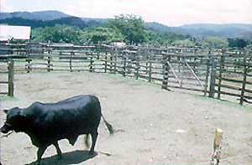  JAMAICA BLACK  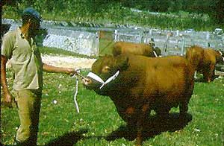  JAMAICA RED  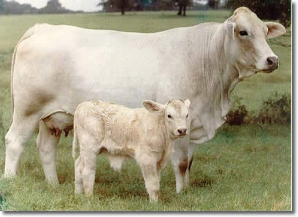  CHARBRAY  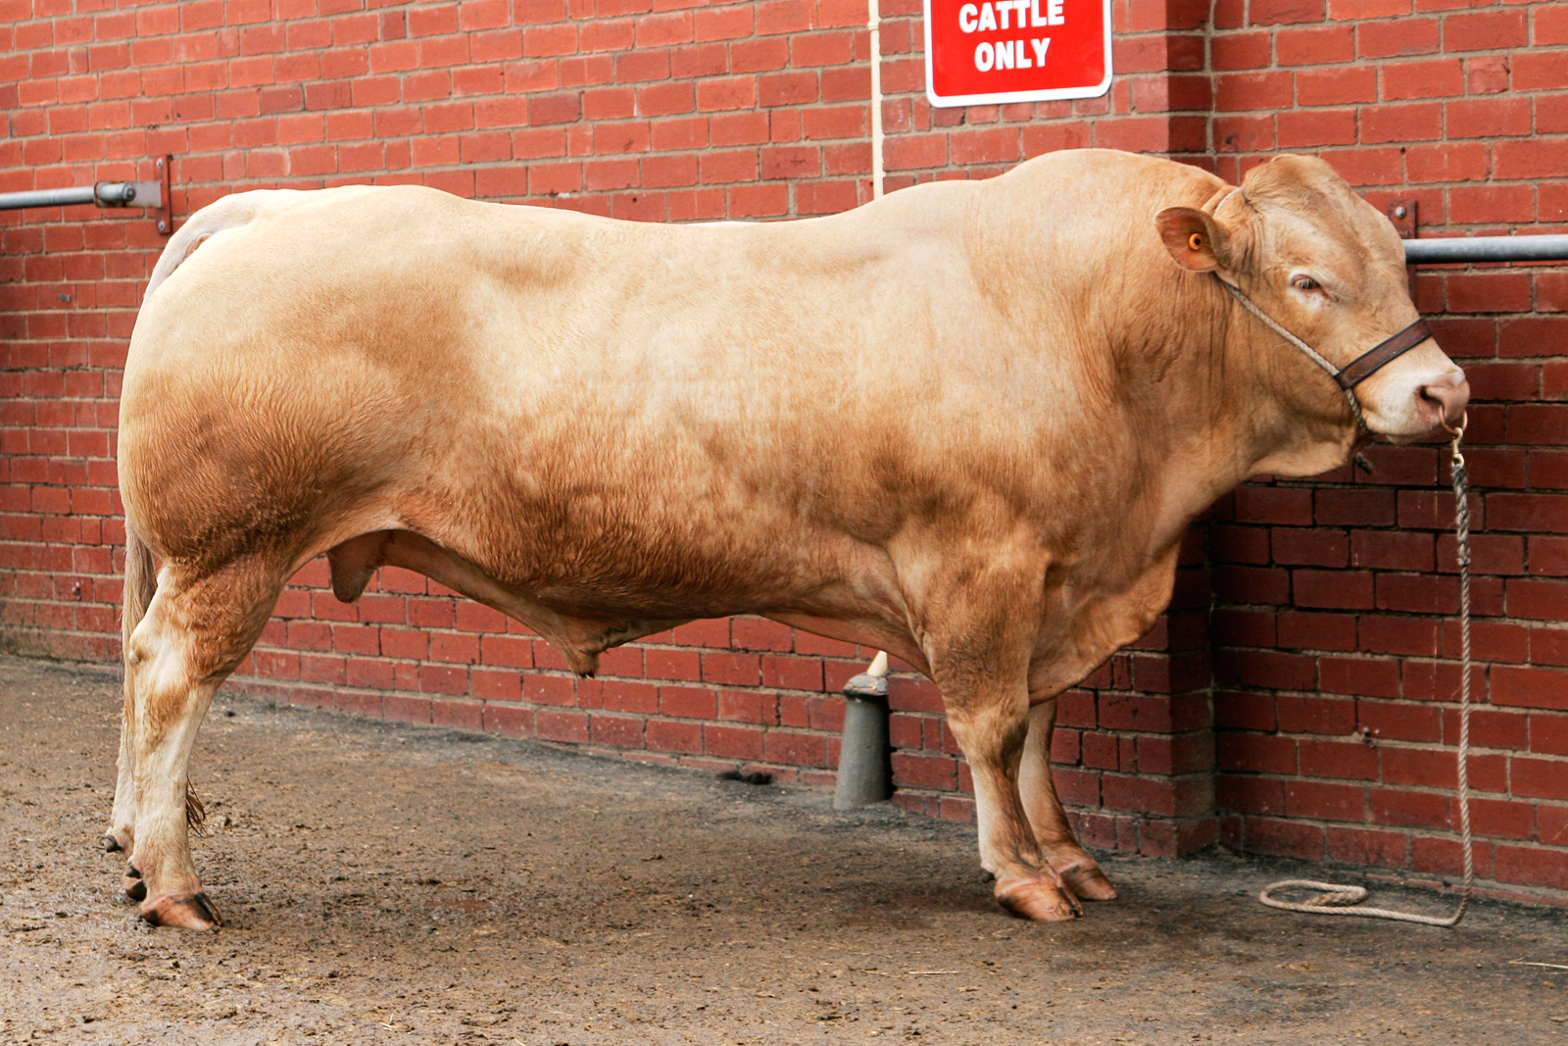  CHAROLAIS  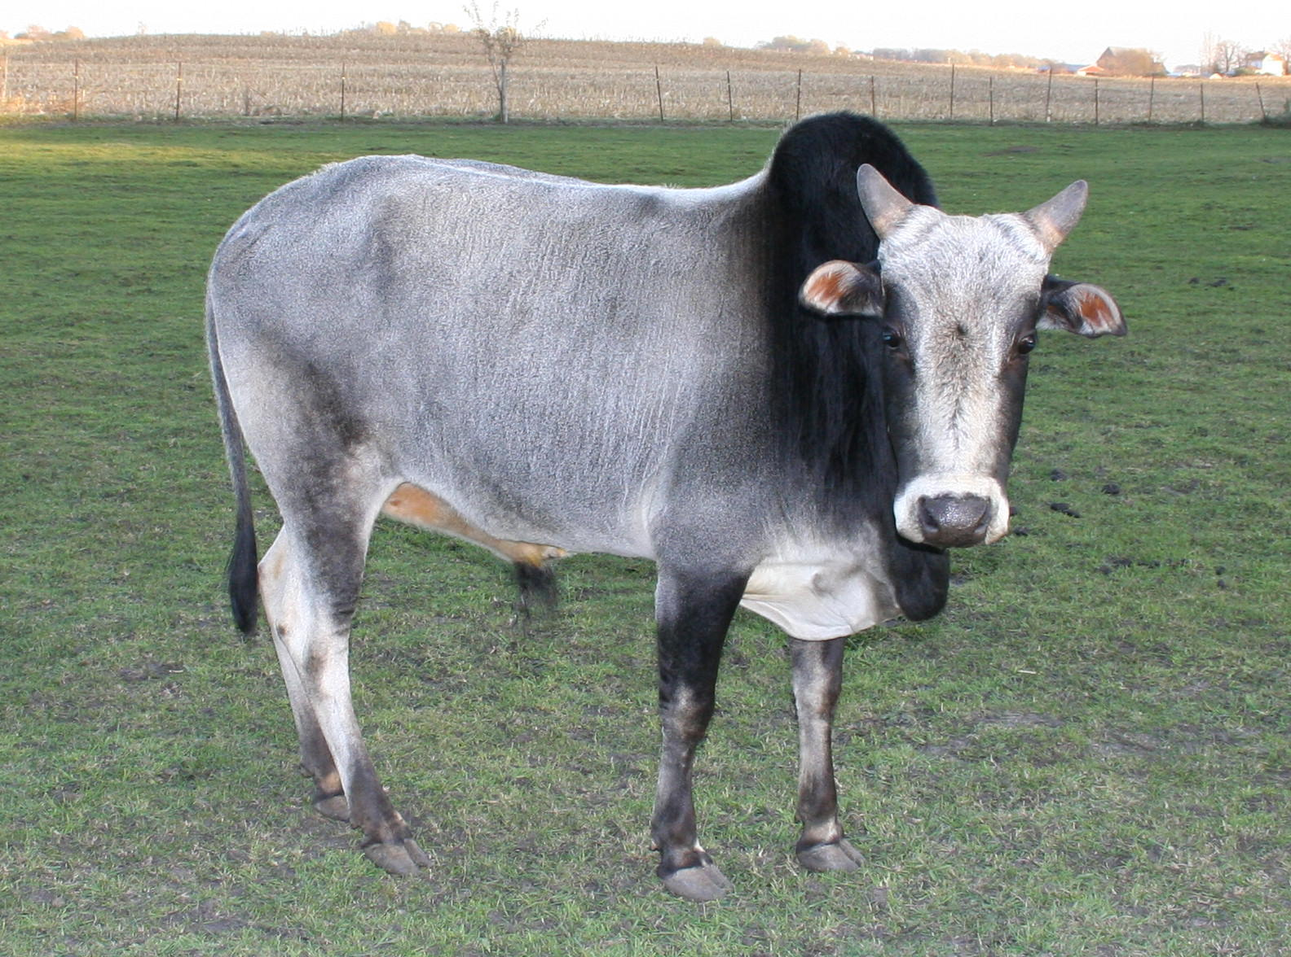  ZEBU
PIGS | LANDRACE  LARGE WHITE  DUROC  HAMPSHIRE | Landrace are white in color. Their ears droop and slant forward with its top edges nearly parallel to the bridge of a straight nose. Landrace, are noted for their ability to farrow and raise large litters.  The Large White is one of the most numerous of all pig breeds, widely used in crossbreeding for intensive pig farming around the world. True to its name the breed is a big white-skinned pig, with erect ears and a dished face. Today it is one of those favored by commercial pig breeders, lending uniformity to pigs produced for meat on a large scale.  Durocs are red pigs with drooping ears. They are the second most recorded breed of swine in the United States and a major breed in many other countries, especially as a terminal sire or in hybrids. Durocs can range from a very light golden, almost yellow color, to a very dark red color that approaches mahogany.  Hampshire hogs are black with a white belt. They have erect ears. The belt is a strip of white across the shoulders that covers the front legs around the body. The Hampshires, which are a heavily muscled, lean meat breed, are the fourth most recorded breed of the pigs in the United States. | 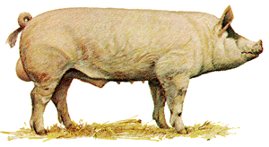  LARGE WHITE  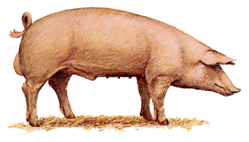  LANDRACE  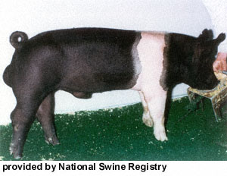  HAMPSHIRE  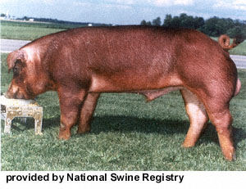  DUROC
GOATS | BRITISH ALPINE  ANGLO NUBIAN  SAANEN  TOGGENBURG | The British Alpine was developed in Great Britain in the early 1900s. The does are good milk producers, with an average fat yield of four percent. Their coat is generally short, fine and glossy. However bucks often have longer hair. The British Alpine should have a black coat with white "Swiss" markings on its head, legs and around its tail.  Its distinguishing characteristics include large, pendulous ears and a "Roman" nose. Due to their Middle-Eastern heritage, Anglo-Nubians can live in very hot climates and have a longer breeding season than other dairy goats. Considered a dairy or dual-purpose breed, Anglo-Nubians are known for the high butterfat content of their milk, although on average, the breed produces less volume of milk than other dairy breeds. Because of its elongated ears and sleek body, the Nubian is occasionally nicknamed the "Lop-Eared Goat" or "Greyhound Goat"  Saanen goats are a white or cream-colored breed of goat, named for the Saanen valley in Switzerland. Saanens are the largest of the goat dairy breeds. Does typically weigh 150 lb (68 kg) or more, with bucks weighing over 200 lb (91 kg). The Saanen breed also produces the most milk as a breed. The Saanen breed is large and big boned but graceful and refined in bone, the ears are erect, and the nose is straight or dished.  The Toggenburg is a Swiss dairy goat from Toggenburg Valley of Switzerland at Obertoggenburg. They are also credited as being the oldest known dairy goat breed. This breed is medium size, sturdy, vigorous, and alert in appearance. The hair is short or medium in length, soft, fine, and lying flat. Its color is solid varying from light fawn to dark chocolate with no preference for any shade. Distinct white markings are as follows: white ears with dark spot in middle; two white stripes down the face from above each eye to the muzzle; hind legs white from hocks to hooves; forelegs white from knees downward with a dark lien (band) below knee acceptable; a white triangle on either side of the tail; white spot may be present at root of wattles or in that area if no wattles are present. | 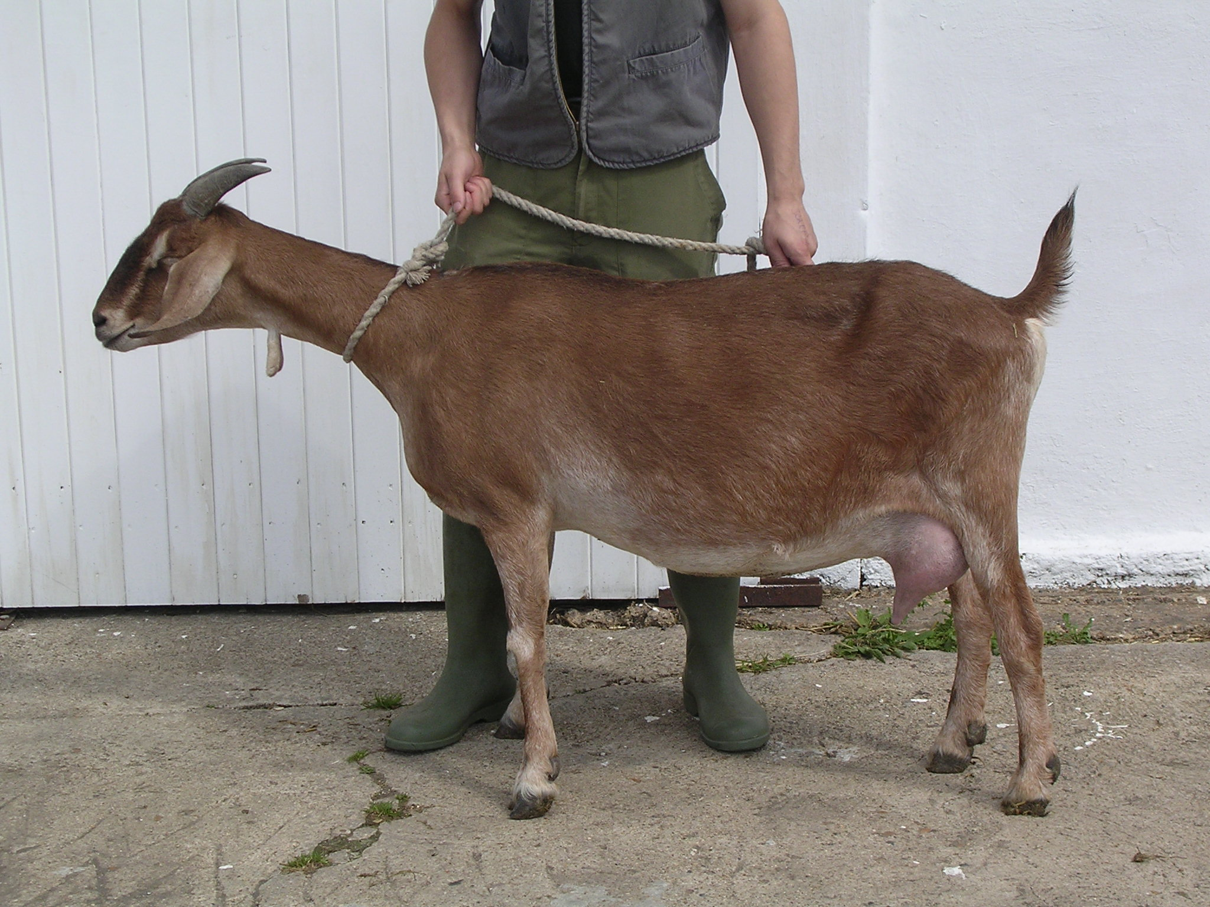  ANGLO NUBIAN  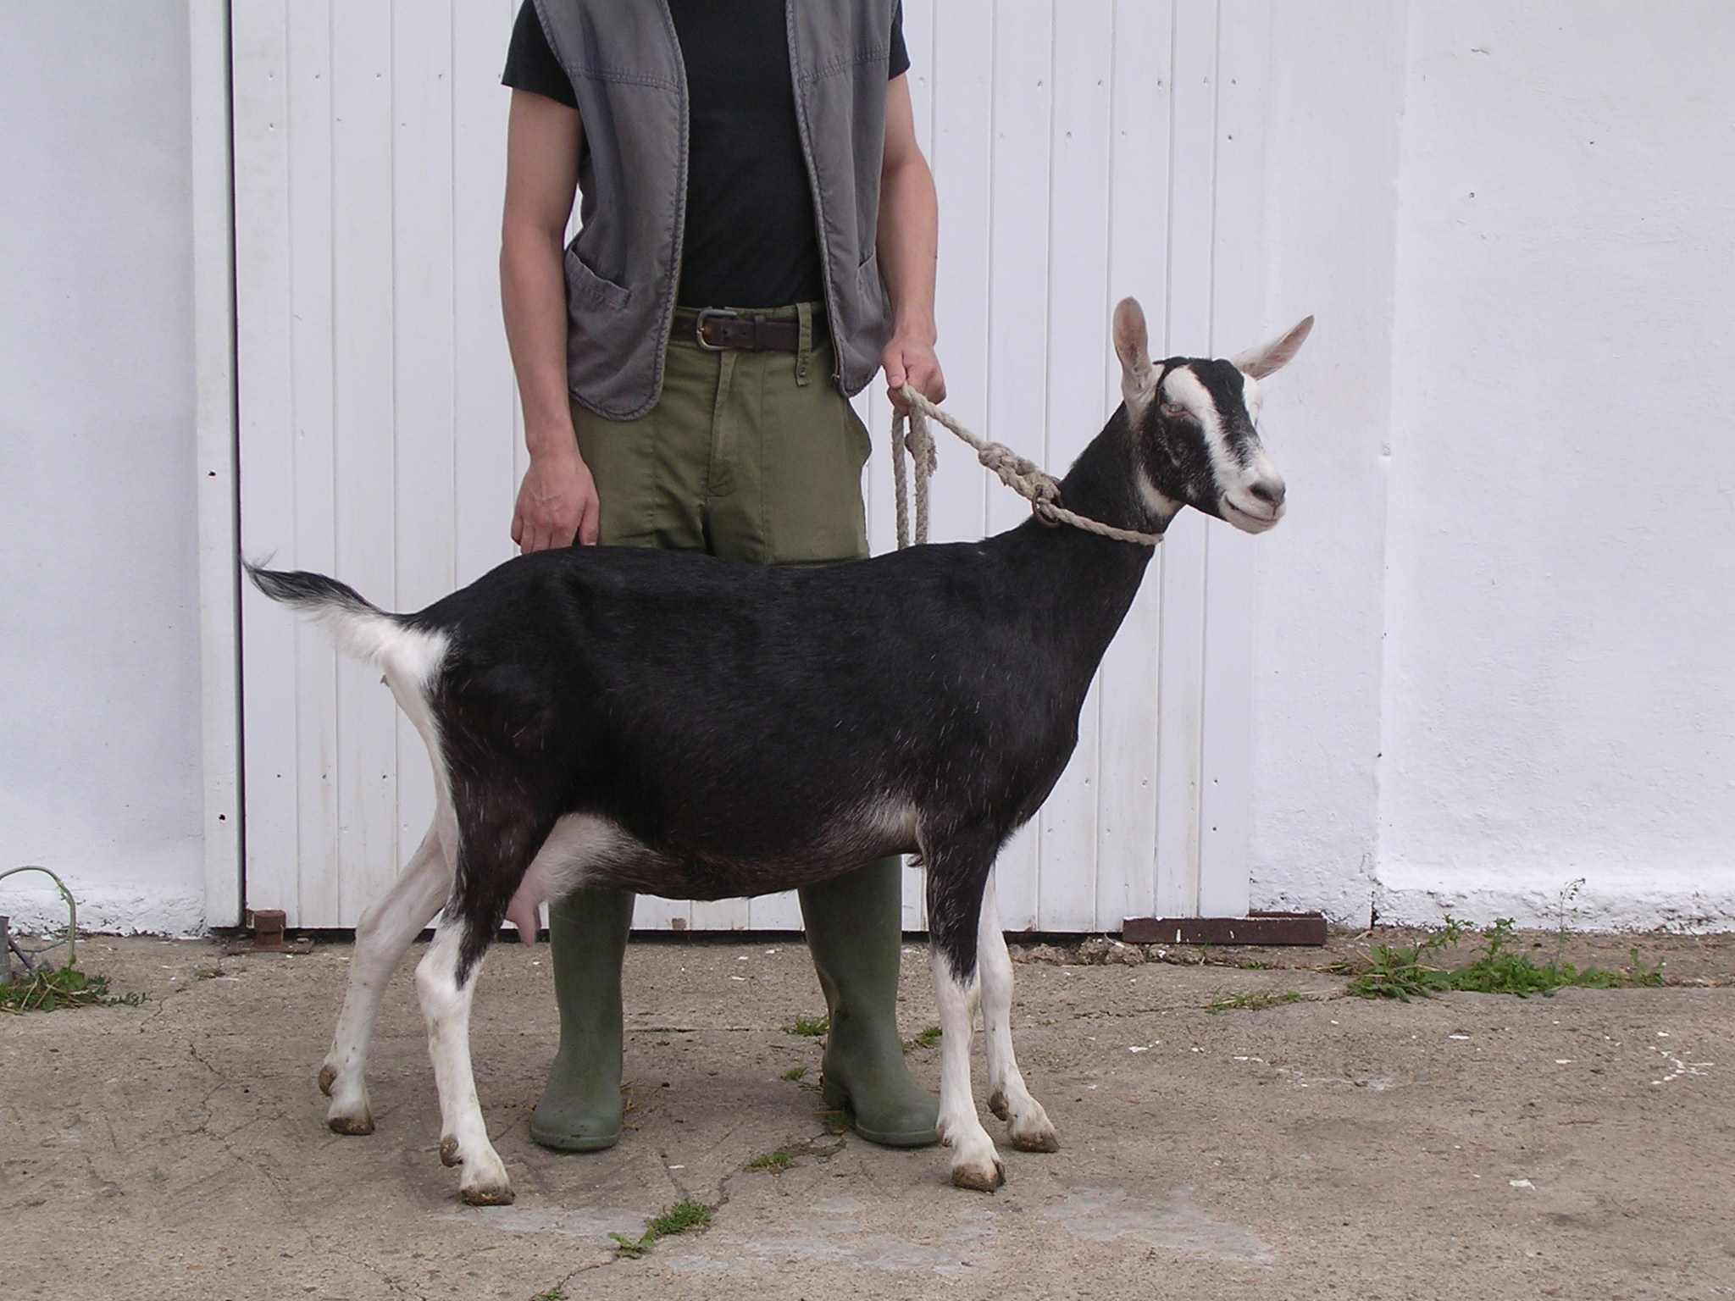  BRITISH ALPINE  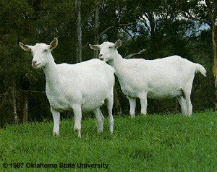  SAANEN  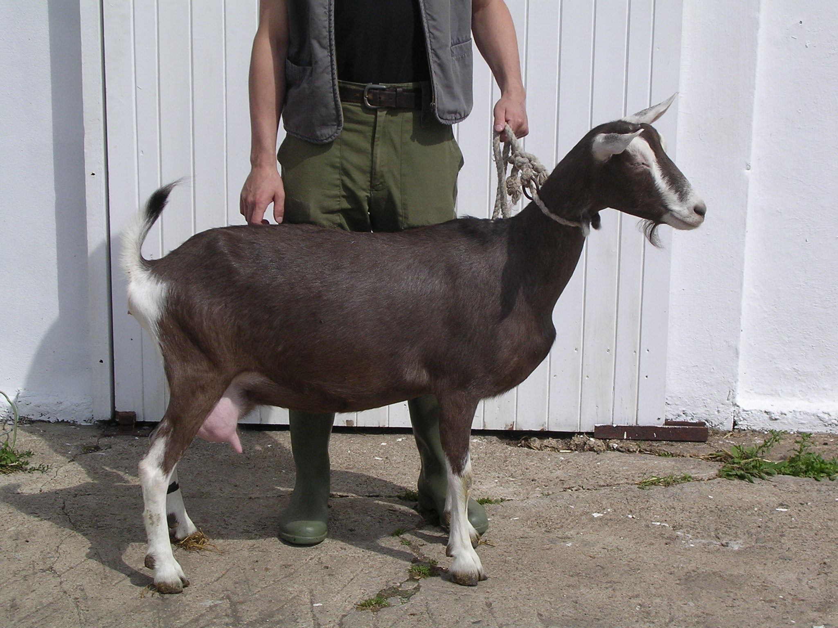  TOGGENBURG
RABBITS | FLEMISH GIANT  NEW ZEALAND WHITE  CLAIFORNIA GIANT | The Flemish Giant rabbit is classified as a giant breed of rabbit. They are long with a large full head and the ears are long and erect. The Flemish Giant rabbit is usually steel grey in color, although other colors are seen. These other colors are sandy, fawn, white, blue and black.  New Zealand white rabbits were bred for their meat and fur, but their body type helped to contribute to them becoming the favorite breed of domestic rabbit. New Zealand whites have well-rounded bodies; slender and muscular faces with round cheeks; large, long back feet; and small, short front feet .They have long ears that stand straight up. Unlike the thick, snowy fur on their bodies, their ears have shorter fur that allows the delicate pale pink of their skin to show through .The most noticeable characteristic of New Zealand white rabbits is their bright eyes, which range in shade from pale pink to bright ruby red.  New Zealand white rabbits have large, broad, and muscular bodies. Bucks (males) weigh between 8-10 pounds, while the does (females) weigh between 9-12 pounds. In addition to their greater size, females are distinguished by the presence of a dewlap, which is flap of fur below the chin that is pulled for a nesting box during pregnancies. | 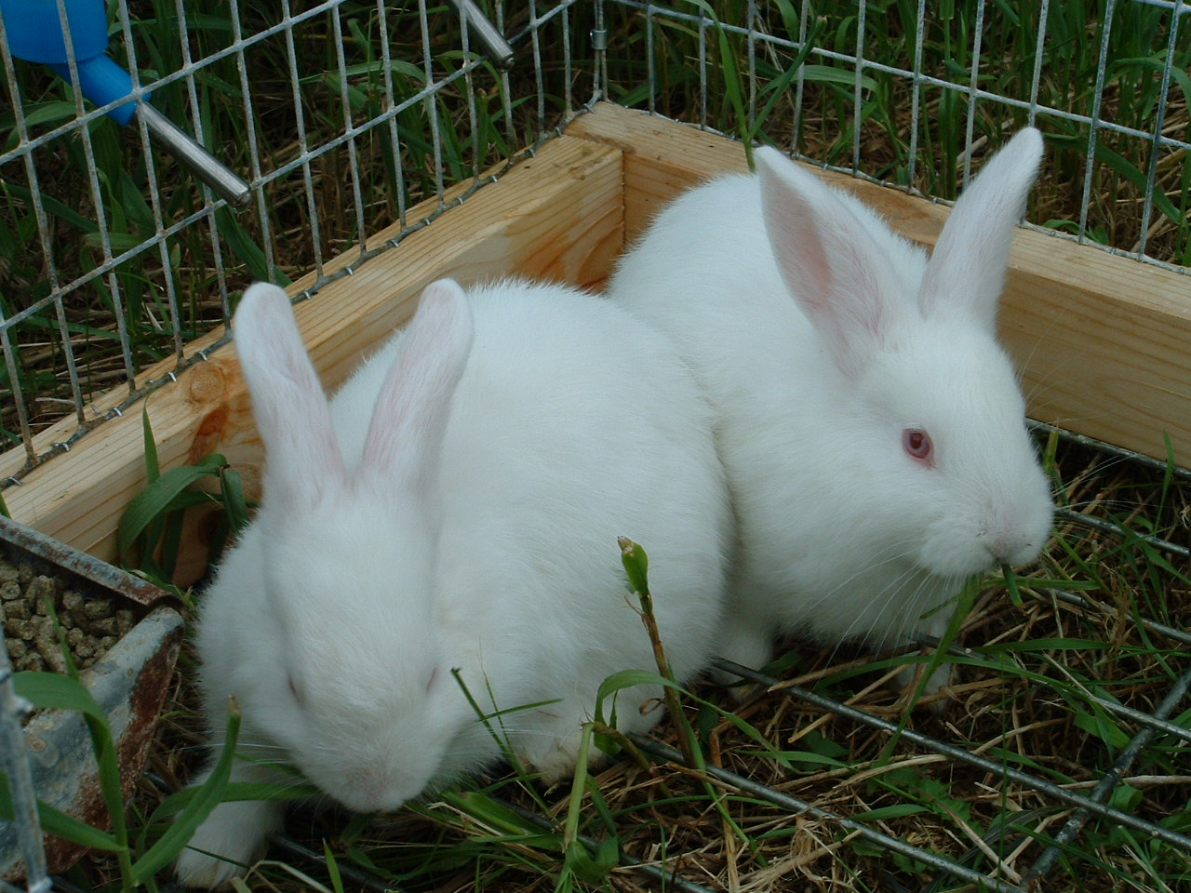  NEW ZEALAND WHITE  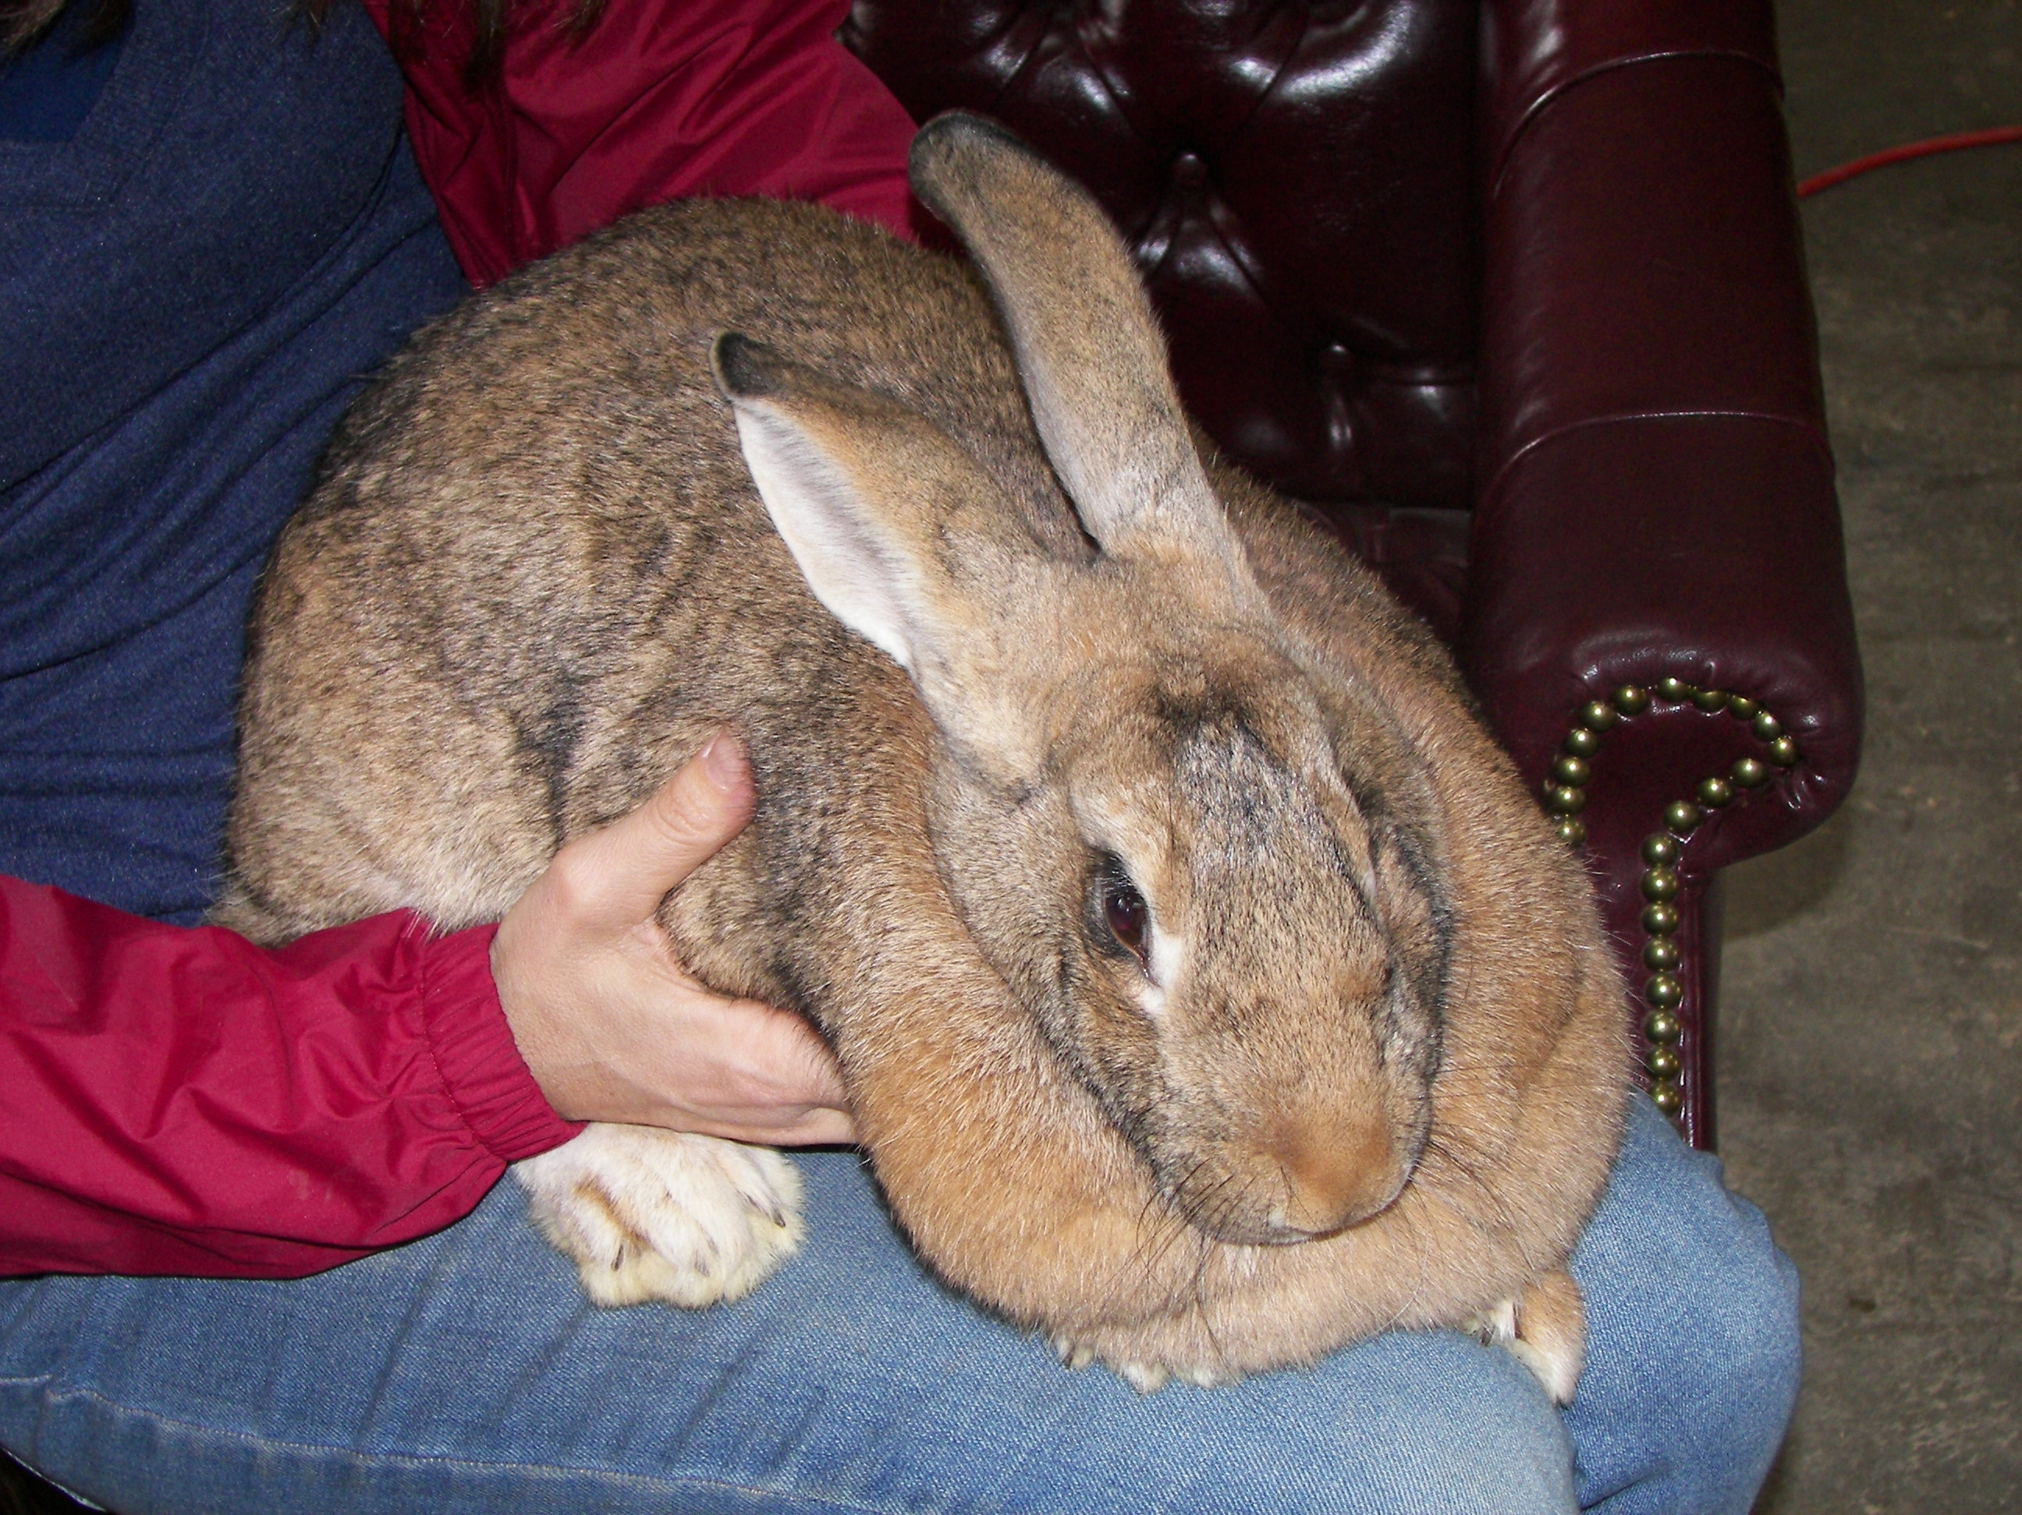  FLEMISH GIANT  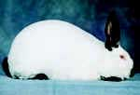  CALIFORNIA GIANT
SHEEP | BARBADOS BLACK BELLY  BLACKHEAD PERSIAN  WEST AFRICAN  KATAHDIN | Black belly sheep are able to tolerate heat and exhibit more stamina than most breeds of sheep. They are fleet of foot and in many ways resemble deer. They are "hair sheep," which means they do not grow wool but have coarse hair instead. They are a perfect choice as they do relatively well on poorer forage, can be raised with very little grain, and do not require intensive management. Black belly sheep range in color from light tan to a dark mahogany red, with black stripes on the face and black legs, belly, inguinal region, chin, and chest. Despite being goat-like in appearance, they are true sheep.  The Blackhead Persian (also known as Swartkoppersie) is a fat-tailed breed of domestic sheep from Africa. The breed is also a type of hair sheep, meaning they do not grow wool and tolerate heat better than wooled breeds and are raised primarily for meat. The Blackhead Persian has a white body and, as their name would suggest, an entirely black head.  Another common breed in T&T is the West African, a reddish brown sheep, with more muscle expression than the Black belly. Producers commonly cross the West African with the Black belly to improve the quality of lambs The West African Dwarf is generally black piebald on white. However, tan piebald on white and the blackbelly pattern are found They have a well-developed throat ruff and are horned. Ewes have mature weights of 25 kg. The females are usually polled. They can be bred at the age of 7 to 8 months. They tend to have a short lambing interval.  Katahdin sheep are a breed of hair sheep developed in the United States. The Katahdin breed originated at the Piel Farm in north central Maine where Michael Piel was an innovator and amateur geneticist who enjoyed raising livestock. Katahdin are hardy, adaptable, low maintenance sheep that produce superior lamb crops and lean, meaty carcasses. They do not produce a fleece and therefore do not require shearing. They are medium-sized and efficient, bred for utility and for production in a variety of management systems. Ewes have exceptional mothering ability and lamb easily; lambs are born vigorous and alert. The breed is ideal for pasture lambing and grass/forage based management systems. They have demonstrated wide adaptability. They were derived from breeds that originated in the Caribbean and British Islands and the state of Maine was their original home. In cold weather, they grow a very thick winter coat, which then sheds during warm seasons. Their smooth hair coat and other adaptive characteristics allow them to tolerate heat and humidity well. Katahdins are also significantly tolerant of internal and external parasites and if managed carefully require only minimal parasite treatment.  Katahdins are docile so are easily handled. | 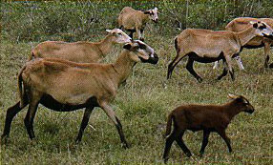  BARBADOS BLACK BELLY  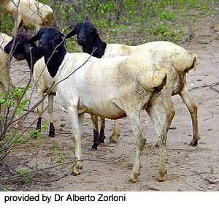  BLACK HEAD PERSIAN  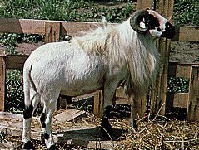  WEST AFRICAN  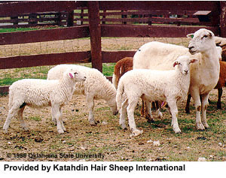  KATAHDIN
CHICKENS | WHITE LEGHORNS  RHODE ISLAND RED  PLYMOUTH ROCK  VANTRESS CROSS | White Leghorns are among the most popular commercial strains of layer chickens worldwide. Leghorns, especially the White ones, are prodigious egg-layers and broodiness (the desire to hatch eggs) has almost completely been bred out of them. Leghorns are usually hatched out in incubators.  The Rhode Island Red is a breed of chicken (Gallus gallus domesticus). They are a utility bird, raised for meat and eggs. The bird's feathers are rust-colored, but darker shades are known, including maroon bordering on black. Their eyes are red-orange and they have yellow feet, with reddish-brown beaks.  The Plymouth Rock is a dual-purpose and makes a great breed for the small farm or backyard flock owner. These chickens are often called Plymouth Rocks, but this title correctly belongs to the entire breed, not just the Barred variety. There are seven varieties of Plymouth Rock chickens: barred, blue, buff, Columbian, partridge, silver-penciled and white. Some varieties are good layers while others are bred principally for meat. They possess a long, broad back; a moderately deep, full breast; and yellow skin and legs. The hens have a deep, full abdomen, which is a sign of a good layer. The face of a Plymouth Rock is red with red ear lobes, a bright yellow beak, bay-colored eyes, and a single comb of moderate size. | 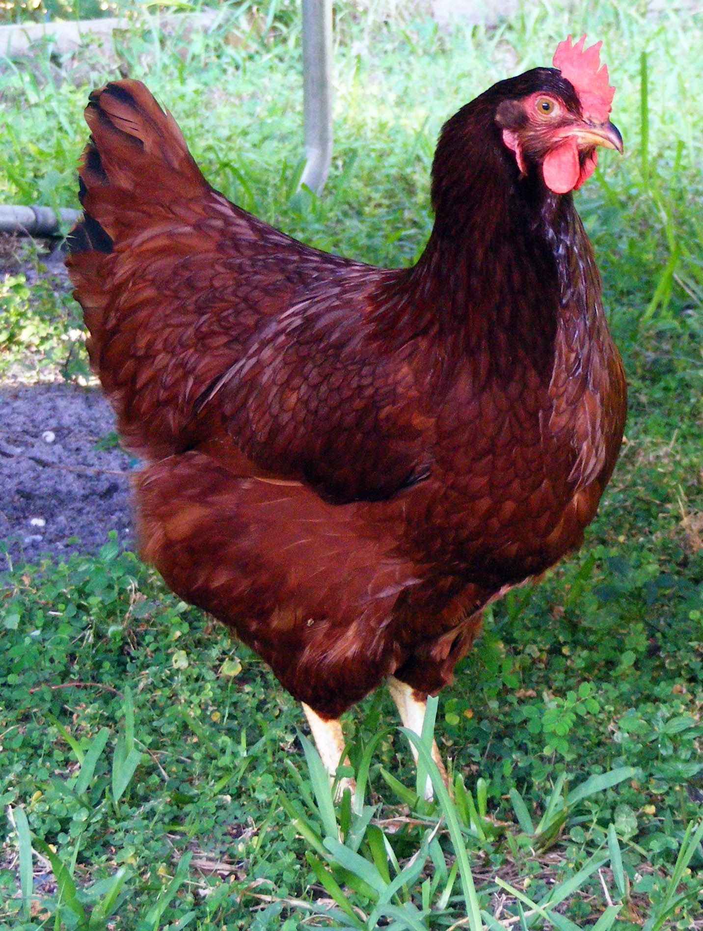  RHODE ISLAND RED  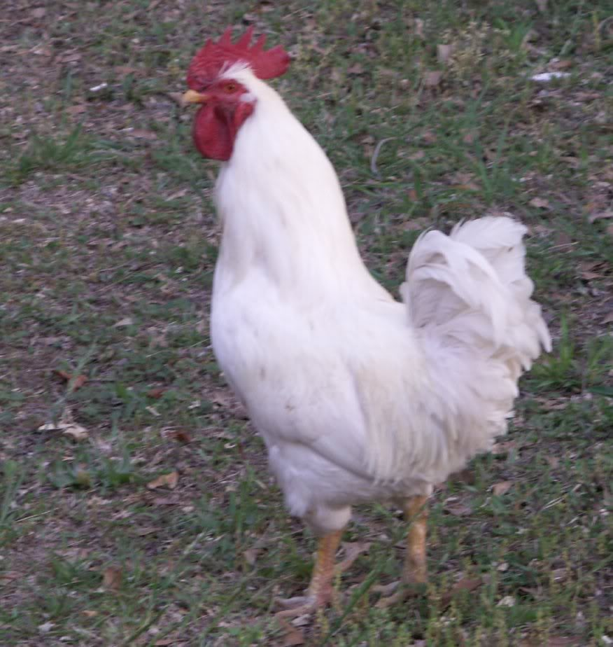  LEGHORN  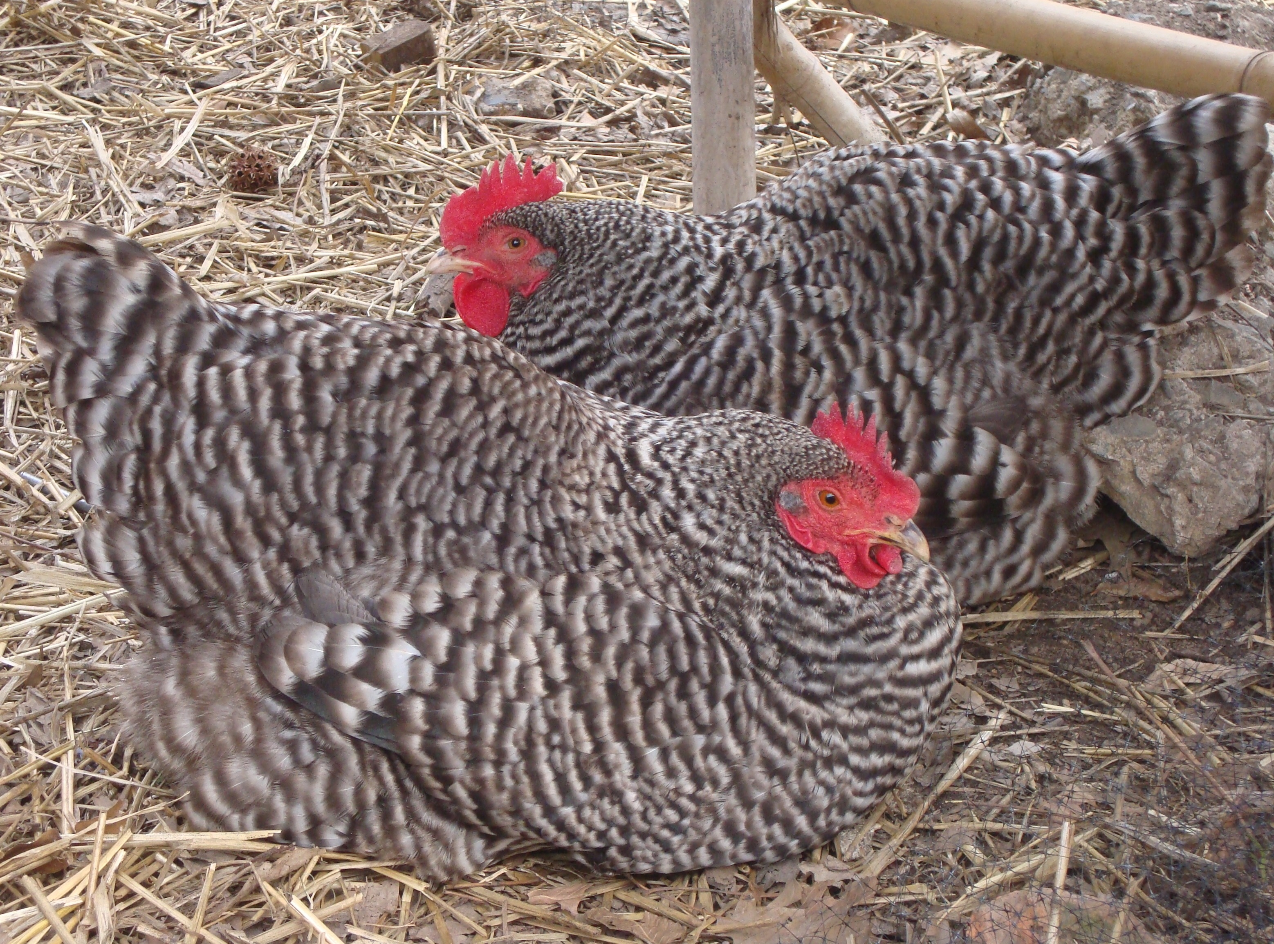  PLYMOUTH ROCK
TURKEYS | BLACK | The Black sometimes referred to as the Black Spanish or the Norfolk Black is a breed of domestic turkey. | 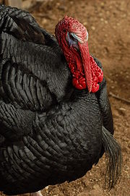  BLACK
DUCKS | MUSCOVY | The Muscovy is a different species of duck altogether - from South America - they are big meaty birds and often good flyers. Muscovy Duck is blackish, with large white wing patches. Domesticated birds may look similar; most are dark brown or black mixed with white, particularly on the head. The drake has a low breathy call, and the hen a quiet trilling coo | 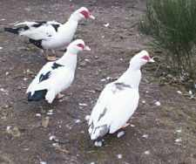  MUSCOVY

