**ELECTRICAL AND ELECTRONIC TECHNOLOGY**

**RESISTORS**

A pure resistor is an electrical component or device that converts all the electrical energy passing through it to heat energy. Its sole functions are to limit the current flow through a circuit and to produce voltage drops at particular circuit points when a current flows through the resistor.

The electrical circuit symbol for the resistor is as shown below in fig1(a) and (b).

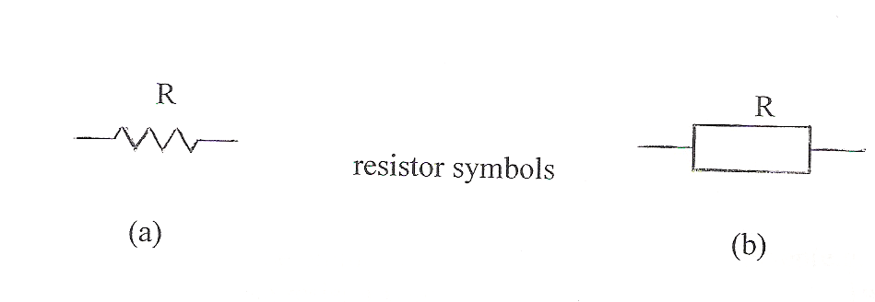

FIG 1

Resistors can be classified into two main groups:

(i) **Fixed type resistors:** these resistors have a fixed or single value resistance in ohms.

(ii) **Variable type resistance:** the value of these resistors can be varied by the use of a

variable knob or slider.

**FIXED RESISTORS:** there are many types of fixed resistors. Some of the most commonly used resistors are:

**Carbon resistor:** This type of resistor is made from carbon composition material

mixed with a binder. Molded and baked. Carbon resistors are

normally employed in electronic equipment such as radios and

televisions. The resistance value of these resistors are identified by

bands printed on the resistor in the form of a colour code. Normal carbon

resistors can sometimes have the adverse effect of creating signal noise in an electronic circuit. An advantage of carbon resistors is that it can be made at high resistance values without being too bulky.

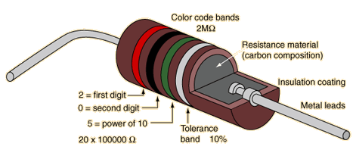

**Carbon resistor**

**Fig 2**

**Metal Film resistors:** These resistors are made by depositing a thin metal film (usually

nickel chromium on an insulating material. These resistors offer

good stability with tolerances between 0.5% to 1%. They are . often used where the accuracy of the value is required.

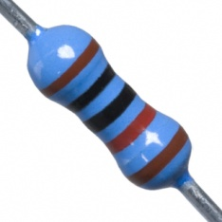

**Metal Oxide resistor**

**Fig 3**

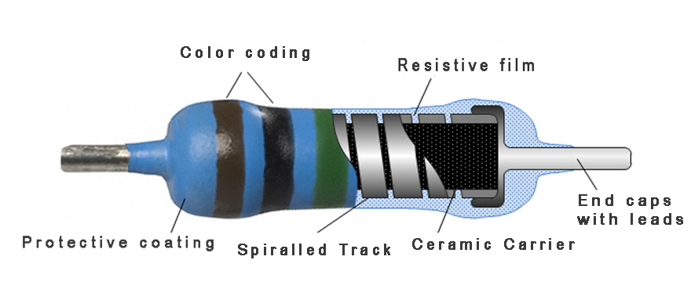

**Cut away view of resistor**

Advantages of metal film resistor

* Low cost
* Generates less noise than carbon resistors
* Can be manufactured at low tolerance
* Low temperature coefficient of resistance (resistance does not change easily with change in temperature)

**Metal Oxide :** A metal oxide film (example, tin oxide) is deposited on a substrate.

These resistors have excellent temperature stability. Fig 4, shows a cut-away

view of the resistor. The length of the helical spiral resistance element

determines the resistance value of the resistor.

This type is a very accurate, ultra-low noise resistor. It uses ceramic substrate coated with a metal film, all encased in an epoxy shell. These resistors are used in precision devices, such as test instruments, digital and analog devices, and audio and video devices. Resistances range from about 0.1 Ω to 2 MΩ, with common power rating from 1/4 to about 1/2 W, and tolerances of +/- 1 percent.

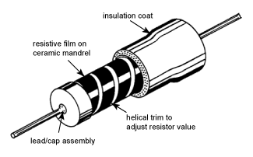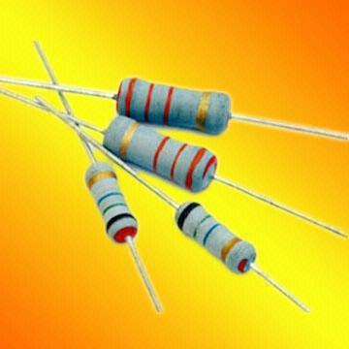

**Fig 4- Metal Oxide film resistor**

**Wire-wound Power resistors**

The ohmic value is printed on the resistors and usually has high wattage ratings since; these resistors are used as heating elements to dissipate heat. The ceramic wire-wound type is shown in Fig 5 (a)

Another type of wire-wound resistor is the cement resistor, Fig 5 (b), which is coated with a cement filling. These resistors are normally employed as load resistors to dissipate heat energy.

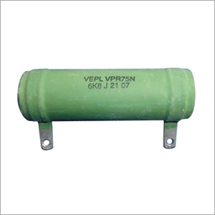 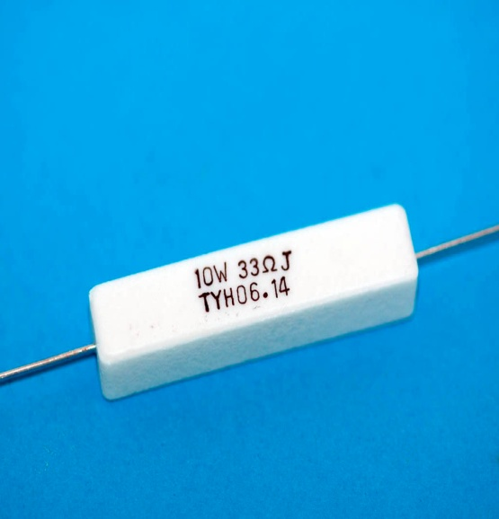

1. **(b)**

**Ceramic wire-wound Resistor cement ceramic wire-wound type**

**Fig 5**

**PURCHASING RESISTORS**

When purchasing resistors, the ohmic value of the resistor must be given (e.g. 50Ω, 500Ω,

1.5k Ω…), and the size of the resistor which is rated in watts (e.g. 1/2watts, 1wattt, 5watts). The watts rating is a power rating which tells how quickly a resistor can give off electrical energy passing through it in the form of heat. If the resistor cannot give off (dissipate) this energy fast enough, the resistor will be destroyed because of excessive heat.

**TEST YOUR KNOWLEDGE**

***QUIZZ 1.***

1. **Name two advantages and one disadvantage of carbon type resistor**
2. **What type of resistance would I used at high wattages to allow for dissipation of heat in the output of a circuit?**
3. **Carbon type resistor**
4. **Metal film resistor**
5. **Metal oxide film resistor**
6. **Wire-wound resistor**
7. **When purchasing resistors what two electrical ratings must be known**

**ANSWERS TO *QUIZZ 1.***

1. *Two advantages of carbon resistors: ( cheap and can be made at high wattages without being too bulky)*
2. (d) wire-wound resistors
3. *Ohmic value and wattage rating*

**RESISTOR COLOUR CODE**

|  |  |  |  |  |
| --- | --- | --- | --- | --- |
| **COLOUR** | **1ST BAND** | **2ND BAND** | **3RD BAND**  **Multiplier** | **4th BAND**  **Tolerance** |
| **Black** | **0** | **0** | **1** |  |
| **Brown** | **1** | **1** | **10** | **1%** |
| **Red** | **2** | **2** | **100** | **2%** |
| **Orange** | **3** | **3** | **1000** | **3%** |
| **Yellow** | **4** | **4** | **10000** | **4%** |
| **Green** | **5** | **5** | **100000** |  |
| **Blue** | **6** | **6** | **1000000** |  |
| **Violet** | **7** | **7** | **10000000** |  |
| **Grey** | **8** | **8** | **100000000** |  |
| **White** | **9** | **9** | **1000000000** |  |
| **Silver** |  |  | **0.01** | **10%** |
| **Gold** |  |  | **0.1** | **5%** |
| **None** |  |  |  | **20%** |

A colour code system is employed to determine the resistance value of the carbon type and metal film resistors. The resistor colour code can therefore be defined as an arrangement of colours on a resistor to indicate the resistance value of the resistor. The resistance colour code is used in carbon and metal film type resistors because of their relatively small sizes. This makes it easier to read than to printed the value on the small surface of the resistor . The colour coding system for the common four band resistor is shown in table1-1.

**TABLE 1-1: Resistor colour code** system

The colour code value is determined using the first three (3) colour bands as follows in the example below :

Example 1.

i. band 1 : Indicates number value ------ blue 6

ii. band 2: Indicates number value------ green 5

iii. band 3 : Indicates multiplier----------- red 00

iv. band 4 : resistor tolerance ------------- gold

Resistance value above = **6500 Ω**

The fourth band of the resistor is the tolerance band. Since resistors are mass produced, the exact coded value read on the resistor is not always the value measured on the resistor. The resistor therefore measures within a range indicated from the fourth band called the **tolerance band**. The tolerance of the resistor indicates how close the measured value is to the coded value of the resistor and is represented as a percentage of the coded value. From example 1, above the tolerance range of the resistor is found as follows:

- fourth band is gold which corresponds to 5% tolerance, hence:

5% of 6800= 340

* therefore, **tolerance minimum value**= 6800**-340= 6460** **Ω**

and **tolerance maximum value= 6800+340=7140** **Ω**

**Tolerance value (range value) of resistor** is between; **6460** **Ω to 7140** **Ω.** This means that the resistor should read between this range of values.

|  |  |  |
| --- | --- | --- |
| **RESISTOR** | **COLOUR CODE VALUE** | **TOLERANECE RANGE** |
| **GREY** |  |  |
|  |  |  |
| **gold** |  |  |
| **SILVER** |  |  |

**TEST YOUR KNOWLEDGE**

***QUIZZ 1.***

**Complete the table below giving the colour code value and tolerance range**

**ANSWERS TO *QUIZZ 2***

|  |  |  |
| --- | --- | --- |
| RESISTOR | COLOUR CODE VALUE | TOLERANECE RANGE |
| **GREY** | 85000000Ω OR 85MΩ | **No fourth band** **Tolerance**:  20% of 85MΩ = 17MΩ  Min. value = 85MΩ - 17MΩ = 68 MΩ  Max value = 85MΩ + 17MΩ = 102 MΩ  **68 MΩ to 102 MΩ** |
|  | 100 Ω | **Red tolerance:** 2% of 100 Ω = 2  Min. value = 100 - 2 = 98 Ω  Max value = 100 + 2 = 102 Ω  **98Ω to 102 Ω** |
| **gold** | 10 Ω | **gold tolerance:** 5% of 10 Ω = 0.5  Min. value = 10 – 0.5 = 9.5 Ω  Max value = 10 + 0.5 = 10.5 Ω  **9.5Ω to 10.5 Ω** |
| **SILVER** | 74000 Ω or 74kΩ | **Silver tolerance:** 10% of 74kΩ = 7.4 kΩ  Min. value = 74000 - 7400 = 66.6kΩ  Max value = 74000 + 7400 = 81.4kΩ  **66.6kΩ to 81.4kΩ** |

**REFERENCES:**

***INTERNET SOURCE:***

* Metal Film resistors <https://www.google.com/search?q=metal+film+resistors&source=lnms&tbm=isch&sa=X&ved=2ahUKEwjys8OX0pDpAhUhnuAKHZbSCbkQ_AUoAXoECBAQAw&biw=1366&bih=608#imgrc=Qo9UsqOqdmnC_M>

Metal oxide resistors

* <https://www.youtube.com/watch?v=XhodKTvbGjU>
* <http://www.resistorguide.com/metal-film-resistor/>

***BOOK RESOURCE:***

* **Harry Mileaf (1995): Electricity One-Seven : Prentice Hall Computer Publishing**