**OHM’S LAW**

The relationship between voltage and current in an electrical circuit was summarized by the French scientist Georg Simon Ohm (1787 – 1854) which stated;

**Ohm’s law states that the voltage(V) across the ends of a conductor is directly proportional to the current(I) flowing through the conductor provided that the temperature and other physical conditions remain constant.**

This statement applies to many conductor materials such metals, however, for some materials, such as semiconductor devices the law does not adequately apply. The law has however become an essential tool for analyzing electrical circuit problems. Materials that obey Ohm’s law completely are referred to as ohmic conductors, and possess graphically a linear relationship (straight line relationship) between voltage and current, **fig1**. The experimental circuit that derives the relationship is shown in **fig1-1**

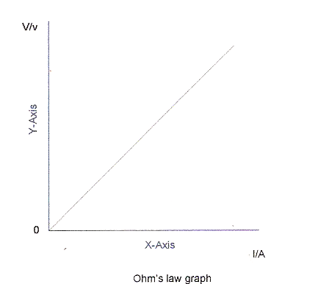

Fig 1.

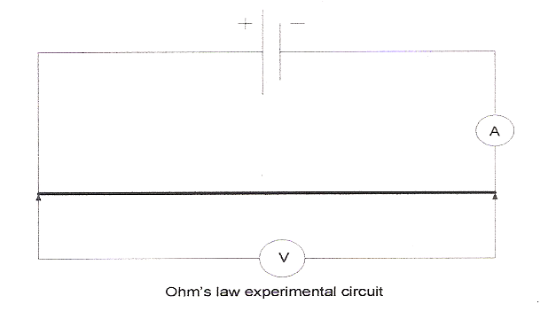

**Fig 1-1**

Mathematically, Ohm’s law relationship is written; **Vα I**, the symbol of proportionality, **α , alpha ,** indicating a direct proportional relationship between current and voltage. The statement basically means, as voltage increases, current increases, and as voltage decreases, current decreases.

The gradient or slope of the graph (V/I) in fig 2, expresses the constant of the relationship. This constant is termed the resistance, of the conductor in ohms(Ω) and completes the Ohm’s law relationship in the equation **V = I R**.

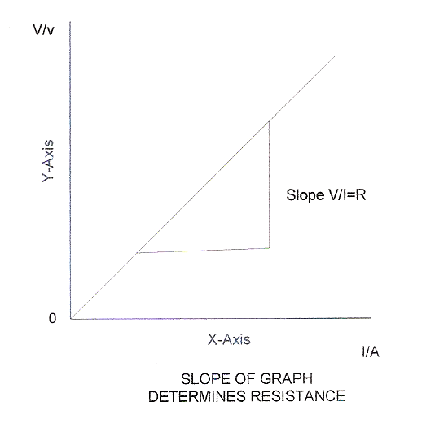

**Fig 2**

**Example problem:**

If the current through a 12Ω resistance element is 0.5 amperes, calculate the voltage across the conductor.

Solution:

V=? I=0.5A, R=12Ω

V =I R; therefore; V= 0.5 x 12 = **6V.**

**Questions:**

1. **State Ohm’s Law**
2. **The graphical relationship between voltage and current is termed a _____________ relationship**
3. **Conductors the follow Ohm’s law are referred to as ________________ conductors**
4. **If the current flowing through a 12Ω resistance is 25 Amperes, calculate the voltage across the resistance**
5. **Calculate the resistance of a heating element supplied by a 120 volts source if the current is 30 Amperes.**

**ANSWER TO QUESTIONS**

1. Ohm’s law states that the voltage(V) across the ends of a conductor is directly proportional to the current(I) flowing through the conductor provided that the temperature and other physical conditions remain constant.
2. **Linear** relationship
3. **Ohmic** conductors

* First state question quantities: R = 12Ω, I = 25 Amp, V =?
* Next write equation: V = I x R
* Solve problem using formula: V = 25 x 12 = **300 Volts**
* V = 120 Volts, I = 30Amps, R =?
* R = V/R, Hence R = 120 V/30 A = **4 Ω**