**Form Three - Term 1**

**Dance**

**Topic - Stimuli**

The following link guides you to a presentation on the topic ‘Stimuli’.

[https://Pixton.com/ic:0kb9aw8a](https://pixton.com/ic:0kb9aw8a)



***NOTE:*** *Look out for the* ***‘Topic’*** *posted on the**blackboard...****Click it***

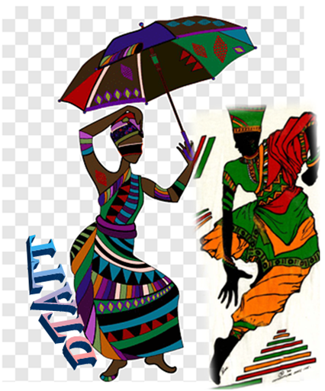

**Compiled and Designed by:**

**Roxanne De Souza-Phillip**

**Dance Teachers’ Association of Trinidad and Tobago**

**(DTATT)**