Name: ______________________________________________ Date: __________________
Sales and Discount Practice
Item & Original Price | Discount  How Much You SAVE  Multiply percent  (in decimal form)  by original price | Subtract Discount from Original Amount | Sales Price
$125 | 30% off  .30 x 125 = $37.50  You save $37.50 | 125.00  _ 37.50  87.50  You only pay $87.50 | - $87.50  - $88.25  - $137.00
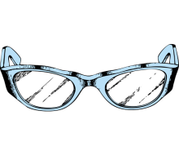  $30 | 15% off |  | - $24.50  - $29.00  - $25.50
  $6.50 | 5% off |  | - $6.18  - $6.45  - $6.17
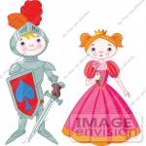  $22.50 | 42% off |  | - $15.05  - $13.05  - $12.50
  $99.95 | 50% off |  | - $50.00  - $49.95  - $49.75
Read the question and circle the correct answer.
- The quotation states that ‘a discount of 2.5 percent is available on accounts paid within one month of date of invoice’.
This is a:
- Cash discount
- Trade discount
- Commission
- Special discount

- The sub-total on the invoice for sports shoes is $6,000.00. If 12 per cent VAT is charged what is the final cost?
- $720..00
- $5280.00
- $8750.00
- 6720.00

- A seller offers 3 per cent cash discount if $1,000.00 of goods are paid for within 10 days. If the buyer ignores this offer, the additional price he will pay for the goods is:
- $3.00
- $10.00
- $30.00
- $100.00

- Samuel increases his order from 2,000 to 5,000 pairs of socks and gets an extra discount. This means he has benefited from
- A trade discount
- A bulk discount
- A special discount
- A cash discount

- Snips hairdressing salon buys shampoos and conditioners from an industry supplier and is rewarded with a 10 per cent discount. This is an example of:
- Cash discount
- Budgeting
- Trade discount
- Special discount.

