Feedback from video presentation

1, Define the term Petty Cash – it is a small sum of money accessible for minor expenses
2. List 3 Examples three examples of minor petty cash expenses: taxi fares, office supplies or postage
- Define the following terms:
- Receipts – money coming into the business
- Disbursements - sums of money given out for payment
- Voucher – a voucher is a small form that documents a disbursement. A voucher authorizes withdrawal from the petty cash till or box and is usually signed by the petty cashier and his or her supervisor
- Float – this is the maximum amount that can be held in the petty cash till or box at any point intime
- Imprest – refers to a type of cash account maintained by an organisation used for paying for small, incidental or routine expenses. The petty cash system is maintained on the imprest system.
- Restore imprest – this refers to the reimbursement or replenishing of funds which have been taken out of petty cash. The imprest is usually restored on a monthly basis.

Response to case study

- Draw up a disbursement sheet accurately with the expenditure headings: travel, postage and
stationery, office sundries.
- Enter the following vouchers.
Voucher 251: Taxi fare $20; Voucher 252: Milk and sugar $6.50; Voucher 253: Registered letter fee $15; Voucher 254: Display card and marker pen $19.35; Voucher 255: Parcel postage $18.60; Voucher 256: Taxi fare $32; Voucher 257: Display folders $22.40; Voucher 258: Magazines for reception $15.
- Calculate the amount spent and how much is required to restore the imprest.
- Use today’s date throughout.

Answer
Question 1 - 2
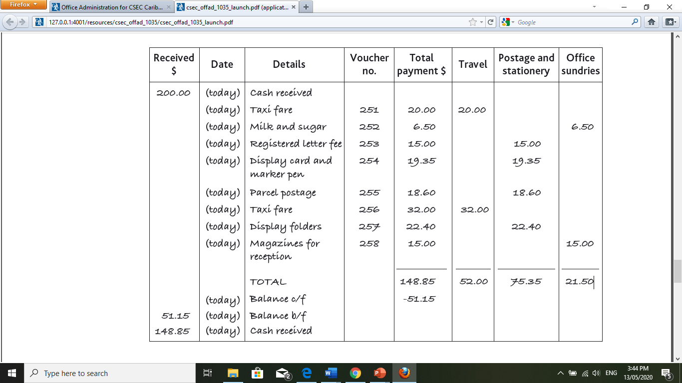

Question 4: Amount spent was: $148.85. This is the amount required to restore the imprest.

