Accounts and Financial Services Lesson 7 – Answer Key

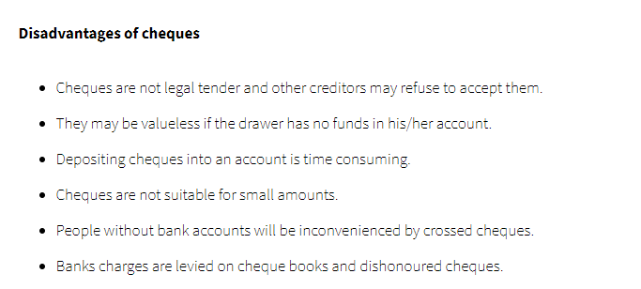

- Differentiate between:

- Post-dated and stale-dated cheques

A post dated cheque is one that is dated ahead of the current date. A stale-dated cheque is a cheque which is invalid because it was drawn a long time before being presented for payment.

- Crossed and certified cheque

A crossed cheque has two parallel lines drawn across the face. A certified or manager’s cheque is one which is issued by the bank upon the request of the customer.

- Explain the term open cheque

An open cheque is a cheque that has not been crossed and allows you to get cash over the counter at the bank.

- Assume that you are J. Jovial. On June 1, 2010 you paid P. Sour $400.00 by cheque for the supply of construction services.

- Use the form provided below to prepare the cheque.

No. 5
June 1, 2010
Date: ____________________________________________________________________
Four Hundred Dollars
$400.00

Received the sum of ________________________________________

_________________________________________________________________________
J. Jovial
From ___________________________________________________________________

P. Sour
Construction services
Memo ________________________________ _______________________________
Signature

