Answer Key

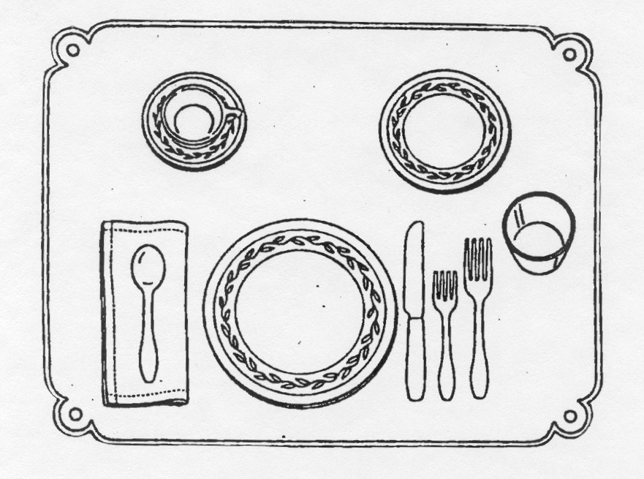

- Spoon should be on the right of the knife

- Forks should be to the left of the plate

- Put fork to the right of the napkin not on it

- Glass at the tip of the knife

- Bread & butter plate above fork on left of dinner plate

- Cup & saucer to the right of the knife and spoon

- Open end of napkin should be toward the plate

